HOW TO DOWNLOAD APPLICATION AND RUN IT LOCALLY
- Go to my repository on GitHub for this version at this URL and download the ZIP file by clicking on "Clone or download" and then selecting "Download ZIP":

https://github.com/sathi-natarajan/Student_Assessment_Platform_Version1

- The downloaded file will then be in your "Downloads" folder. Extract it in that folder itself and you will get a subfolder called "Student_Assessment_Platform_Version1-master". Go into that subfolder and also into one more subfolder of the same name. It will now look like this:
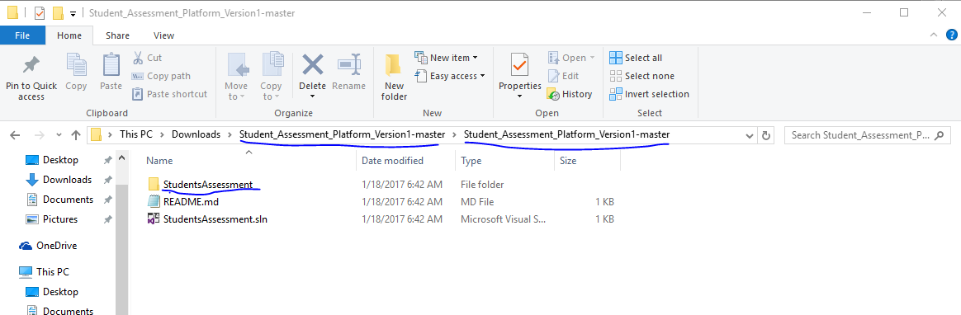

- Then, go into "Student Assessment" subfolder of it also. If you were able to do all these up to here, it signifies the file has been downloaded and extracted to the intended (by me) location correctly for below use.

- Open a command prompt window and copy the line below in its entirety and paste it into that window. And hope “Varun” is the user name. Otherwise, replace that word (in italics below) with the correct user name shown in the address bar of Windows Explorer:

iisexpress /path:"C:\Users\Varun\Downloads\Student_Assessment_Platform_Version1-master\Student_Assessment_Platform_Version1-master\StudentsAssessment" /port:8081

and press Enter key (read note below before that)

NOTE:- Before pressing Enter key, make sure the part “/port:8081” (in bold above) is in that line you copied and pasted. Leaving it out is a cause of inaccessible website.

- Now fire up Google Chrome browser and type this URL into its address bar and press Enter.
http://localhost:8081

- Now the web application's default page will show up. Click "Teachers Login" to go to the login page and type "teacher1" and "teacher" for user name and password respectively.

Finally, be sure not to close the command prompt window in which you typed and started "iisexpress". Closing this window is one cause of not being able to access a web resource.

